**Практико-ориентированные задания, направленные на формирование читательской грамотности**

**Учитель: Боброва Т.В.**

**Задание № 1 Группа умений: поиск и нахождение информации.**

**1. «Английский язык. 5 класс» (авторы: Лапицкая Л. М. [и др.], Минск: Вышэйшая школа, 2020), упр.1b, стр. 54.**

Once upon a time there lived two cousins. They were called (их звали) Country Mouse and Town Mouse. Country Mouse lived in a little hole (нора) in a country house. Town Mouse lived in a hole in a big town house.

One day Country Mouse visited his cousin in town. “Hello! Come in,” said Town Mouse. “I think, you’ll love the town. It’s so interesting here!”

Town Mouse made a fantastic dinner of jam, biscuits and cola, chocolate cake and ice cream. Country Mouse didn’t like the food – it was too sweet1 for him. At night Country Mouse didn’t sleep. “It’s too noisy and there are too many lights!” he thought.

The next day the cousins went to the amusement park. Country Mouse saw swings, slides, a big wheel, and a merry-go-round. They were horrible! Country Mouse didn’t like the big wheel. It was too big. He didn’t like the merry-go-round. It was too noisy.

He didn’t like the amusement park. There were too many people, dogs and cats. He was very tired.

At night Country Mouse had a dream. He saw his nice little hole and beautiful green fields.

In the morning he said goodbye to his cousin and went home.

**2. «Multiple Choice» Clouds**

**3. Students are to choose the correct answer. Then fill in the blanks.**

**4. Tick the correct words. Then complete the sentences. This task can help you to retell the story.**

1. Town Mouse is Country Mouse’s … .

cousin

friend

grandad

2. Country mouse lived in a little hole in a … .

little flat

big building

country house

3. Town Mouse lived in a hole in a … .

little building

little country house

big town house

4. One day Country Mouse comes to Town Mouse’s … .

school

home

shop

5. Town Mouse made a fantastic dinner of … .

jam,

biscuits and cola,

chocolate cakes

meet, cheese,

bread and butter

sandwiches and tea

seeds, apples,

carrots, cucumbers

and water

6. Country Mouse didn’t like the food – it was … for him.

too spicy

too salty

too sweet

7. At night Country mouse didn’t sleep because … . (Tick two)

it was too hot

there were too many lights

it was too noisy

5. The next day two cousins went … .

to the theatre

to the cinema

to the amusement park

6. After a day in the amusement park Country Mouse was … .

very tired

very happy

very excited

7. There were too many … .

shocks

buildings

people, cats and dogs

8. At night country mouse had a dream he saw … .

his mum

people, dogs and cats

his nice little hole

**Задание № 2 Группа умений: интерпретация и интеграция информации.**

**1. «Английский язык. 5 класс» (авторы: Лапицкая Л. М. [и др.], Минск: Вышэйшая школа, 2020), упр.1b, стр. 54.**

Once upon a time there lived two cousins. They were called (их звали) Country Mouse and Town Mouse. Country Mouse lived in a little hole (нора) in a country house. Town Mouse lived in a hole in a big town house.

One day Country Mouse visited his cousin in town. “Hello! Come in,” said Town Mouse. “I think, you’ll love the town. It’s so interesting here!”

Town Mouse made a fantastic dinner of jam, biscuits and cola, chocolate cake and ice cream. Country Mouse didn’t like the food – it was too sweet1 for him. At night Country Mouse didn’t sleep. “It’s too noisy and there are too many lights!” he thought.

The next day the cousins went to the amusement park. Country Mouse saw swings, slides, a big wheel, and a merry-go-round. They were horrible! Country Mouse didn’t like the big wheel. It was too big. He didn’t like the merry-go-round. It was too noisy.

He didn’t like the amusement park. There were too many people, dogs and cats. He was very tired.

At night Country Mouse had a dream. He saw his nice little hole and beautiful green fields.

In the morning he said goodbye to his cousin and went home.

**2. «Character» Clouds**

**3. Students are to correlate the given information with the appropriate character, find and write down text evidence to prove the information. The information is on the pictures of suns. Students should glue them to any of the cloud pictures of the appropriate character and fill in the text evidence column. Pictures of the suns should be cut out in advance.**

**4. Decide if the information on the «suns» is about Town Mouse or Country Mouse. Then glue each «sun» to any «cloud» of the right character.**

**Character Clouds**

Text Evidence

_________________________________

_________________________________

_________________________________

_________________________________

_________________________________

Text Evidence

­­­­­­_________________________________

_________________________________

_________________________________

_________________________________

_________________________________

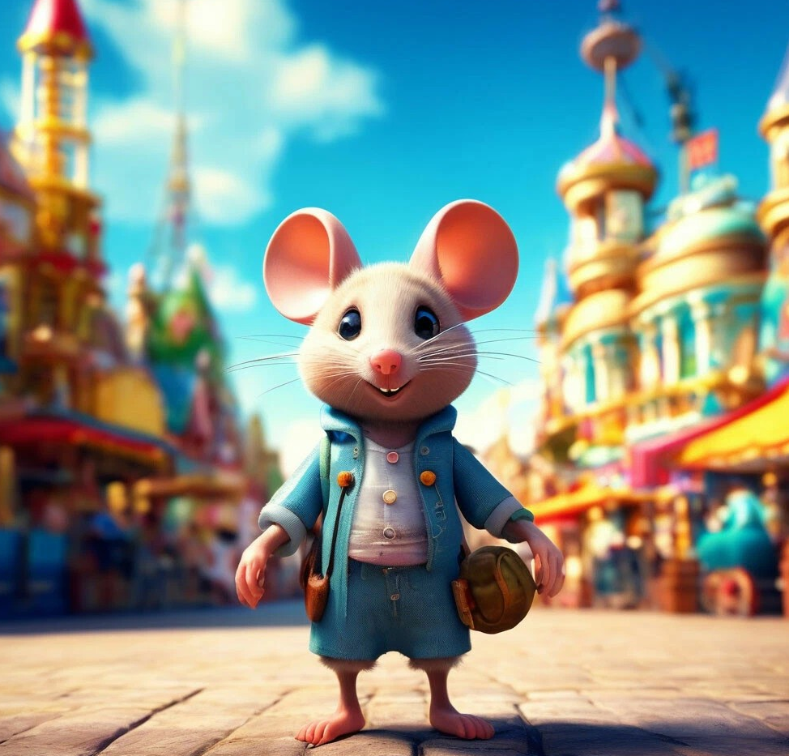

Text Evidence

­­­­­­_________________________________

_________________________________

_________________________________

_________________________________

_________________________________

Text Evidence

_________________________________

_________________________________

_________________________________

_________________________________

________________________________

_________________________________

**Character Clouds**

Trait

Text Evidence

_________________________________

_________________________________

_________________________________

_________________________________

________________________________

Text Evidence

_________________________________

_________________________________

_________________________________

_________________________________

________________________________

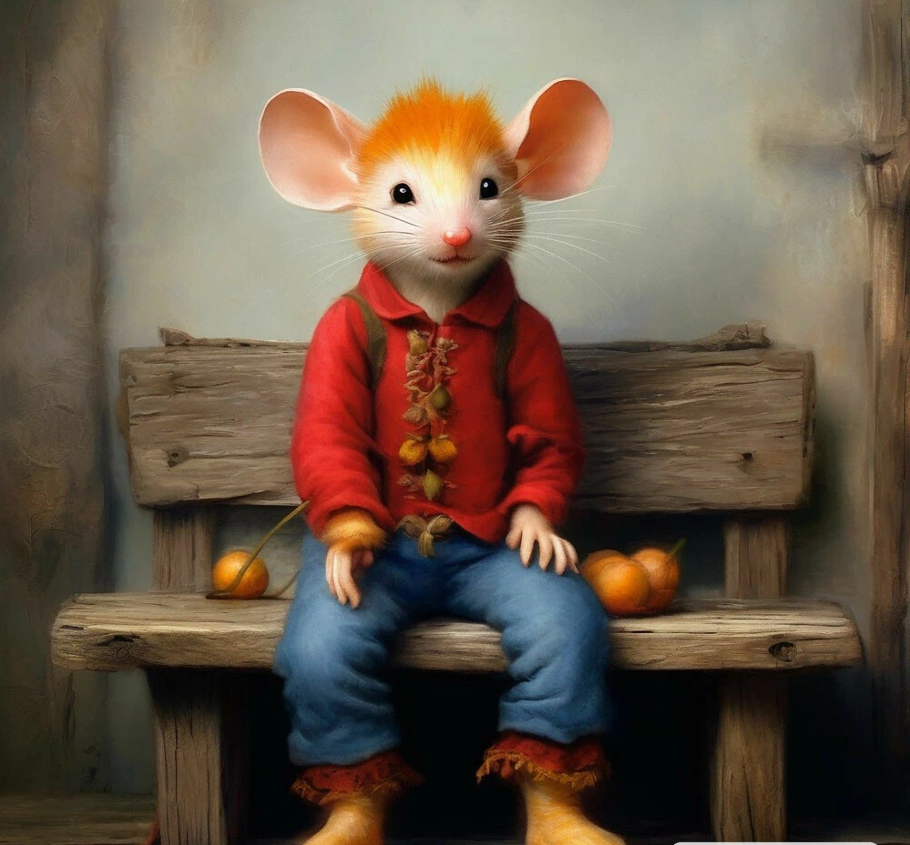

Text Evidence

_________________________________

_________________________________

_________________________________

_________________________________

________________________________

Text Evidence

_______________________________

_________________________________

_________________________________

_________________________________

________________________________

likes

nature

likes

the town

has

unhealthy

lifestyle

has

healthy

lifestyle

likes

amuse-

ment

likes

simple

life

can’t live

in the town

kind

to his

cousin

**Задание № 3. Группа умений: оценка содержания и формы текста. (Two options of the task are presented)**

**1. «Английский язык. 5 класс» (авторы: Лапицкая Л. М. [и др.], Минск: Вышэйшая школа, 2020), упр.1b, стр. 54.**

Once upon a time there lived two cousins. They were called (их звали) Country Mouse and Town Mouse. Country Mouse lived in a little hole (нора) in a country house. Town Mouse lived in a hole in a big town house.

One day Country Mouse visited his cousin in town. “Hello! Come in,” said Town Mouse. “I think, you’ll love the town. It’s so interesting here!”

Town Mouse made a fantastic dinner of jam, biscuits and cola, chocolate cake and ice cream. Country Mouse didn’t like the food – it was too sweet for him. At night Country Mouse didn’t sleep. “It’s too noisy and there are too many lights!” he thought.

The next day the cousins went to the amusement park. Country Mouse saw swings, slides, a big wheel, and a merry-go-round. They were horrible! Country Mouse didn’t like the big wheel. It was too big. He didn’t like the merry-go-round. It was too noisy.

He didn’t like the amusement park. There were too many people, dogs and cats. He was very tired.

At night Country Mouse had a dream. He saw his nice little hole and beautiful green fields.

In the morning he said goodbye to his cousin and went home.

**Option 1**

**2. «Theme and Main Idea» Clouds**

**3. Students are to choose which theme and main idea is more suitable for the text. Students should glue the appropriate «cloud» with the theme and the main idea to the «suns» or give their own answers. Pictures of the suns and clouds should be cut out in advance.**

**Option 2**

**2. «Pros and cons» Clouds**

**3. Students are to write down the advantages and disadvantages of living in the town and in the country in the pictures of clouds. Then they are to share their ideas and write down some more advantages and disadvantages.**

4. **Glue the with the right theme of the text to the**

Wildlife

Family

Theme

Town and country

life

Friendship

**Glue the with the right main idea of the text to the**

Town life is better

Country life is better

Main Idea

People from town

and country

can’t be friends

Town life

and country life

have

advantages and

disadvantages

Country life is better

because

1.________________________

2.________________________

3.________________________

Town life is better

because

1.______________________

2.______________________

3.______________________

Country life is worse

because

1._________________________

2._________________________

3.__________________________

Town life is worse

because

1._______________________

2._______________________

3._______________________

**Задание № 4 Группа умений: использование информации текста для решения практических задач.**

**1. «Английский язык. 5 класс» (авторы: Лапицкая Л. М. [и др.], Минск: Вышэйшая школа, 2020), упр.1b, стр. 54.**

Once upon a time there lived two cousins. They were called (их звали) Country Mouse and Town Mouse. Country Mouse lived in a little hole (нора) in a country house. Town Mouse lived in a hole in a big town house.

One day Country Mouse visited his cousin in town. “Hello! Come in,” said Town Mouse. “I think, you’ll love the town. It’s so interesting here!”

Town Mouse made a fantastic dinner of jam, biscuits and cola, chocolate cake and ice cream. Country Mouse didn’t like the food – it was too sweet for him. At night Country Mouse didn’t sleep. “It’s too noisy and there are too many lights!” he thought.

The next day the cousins went to the amusement park. Country Mouse saw swings, slides, a big wheel, and a merry-go-round. They were horrible! Country Mouse didn’t like the big wheel. It was too big. He didn’t like the merry-go-round. It was too noisy.

He didn’t like the amusement park. There were too many people, dogs and cats. He was very tired.

At night Country Mouse had a dream. He saw his nice little hole and beautiful green fields.

In the morning he said goodbye to his cousin and went home.

**2.** **Project «Successful Excursion of Country Mouse across Mogilev»**

**3. Students are to write invitation letters. They are to invite Country Mouse to Mogilev. Then they are to create their own itineraries for a successful excursion of Country Mouse across the city. They should take into account likes and dislikes of the mouse. Student may work individually, in pairs or groups. Using snaps and pictures is appreciated.**

Invitation

Letter

**Dear Country Mouse** ___________________________________________________________

___________________________________________________________

___________________________________________________________

___________________________________________________________

____________________________________________________________­­­­­­­­­­­­­­­­­­­­­­­­­­­­­­­­­­­­­­­­­­­



***Love***

Your friend from Belarus

_________

**Itinerary**

**Itinerary**

*Activities*

*Day 1*

*Location*

*____________________*

*_____________________*

*Day 3*

*Day 2*

*Activities*

*Location*

*_____________*

*___________*

*Activities*

*Location*

*_____________________*

*_____________________*